**A Mini Project Report**

**on**

**ADAPTIVE FAN**

**By**

**<VENKATESH SAMHITHA>-<1602-13-733-057>**

**<GANNU VINEEL>-<1602-13-733-058>**

**<KAGITHA VINEETHA>-<1602-13-733-059>**



**Department of Computer Science & Engineering**

**Vasavi College of Engineering**

**(Autonomous)**

**Ibrahimbagh, Hyderabad-31**

**2016**

**Acknowledgement:**

It is a genuine pleasure to express my deep sense of thanks and gratitude to my coordinators. Their dedication and keen interest above all their over whelming attitude to help their students had been solely and mainly responsible for completing my work

**Table of Contents:**

1.0 List of figures 5

2.0 Abstract 6

3.0 Introduction 7

1. SRS 8

4.1 Introduction

4.1.1 Purpose 8

4.1.2 Scope 8

4.1.3 Definitions, Acronyms and Abbreviations 9

4.1.4 References 9

4.1.5 Overview 9

4.2. General Description

4.2.1 Product Perspective 9

4.2.2 Product Functions 9

4.2.3 User Characteristics 10

4.2.4 General Characteristics 10

4.3. Specific Requirements

4.3.1 External Interfaces 10

4.3.2 Functions 11

4.3.3 Design Constraints 11

4.4 Appendix

A.1Use Case Diagram 12

A.2 Adaptive Fan Process Diagram 13

5.0 System Design 14

6.0 Conclusion 15

7.0 References 16

1. **List of Figures:**

A.1Use Case Diagram 12

A.2 Adaptive Fan Process Diagram 13

**2.0 Abstract:**

The idea behind the project ADAPTIVE FAN is to control the speed of the fan using micro controller based on the variation in temperature detected by the temperature sensor. In this project we are using analog temperature sensor which senses the temperature around and the output of this sensor will be connected to a microcontroller. The AC to DC convertor converts the analog signals to digital format. This will be used by microcontroller to generate control logic, here control logic refers to the implementation designed and coded involving all the constraints needed for different ranges of temperature. This helps in controlling variable speed DC motor of the fan through a motor driver stage.

**3.0 Introduction:**

In many restaurants, bakeries and various working places we see continuously running of fans and Exhaustive adjusters. They result in more power consumption when not in appropriate use also, so a temperature sensor which senses the room temperature and thereby manipulate the speed of fans without any external source of action is the basic idea behind this project.

This can be applied in case of a huge set of fans all connected across a switch to regulate their speed altogether by sensing the temperature around.

**4.0 Software Requirements Specification:**

**4.1. Introduction**

4.1.1 Purpose:

Basic Description of Problem:

In many restaurants, bakeries and various working places we see continuously running of fans and Exhaustive adjusters. They result in more power consumption when not in appropriate use also, so a temperature sensor which senses the room temperature and thereby manipulate the speed of fans without any external source of action is the basic idea behind this project.

This can be applied in case of a huge set of fans all connected across a switch to regulate their speed altogether by sensing the temperature around.

**4.1.2 Scope:**

The purpose of this specification is to document requirements for a system to regulate the speed of fan. The scope of the project is to identify its usage places and describe how handy it is to use.

The product will be labelled the *Adaptive fan.* The Adaptive fan will try to reduce unnecessary power consumption by fans and exhaustive adjusters which run continuously in many working places, This product helps those fans to sense the temperature around and regulate their speed which is appropriate in that temperature.

Currently using fans can be regulated or manipulated only on an external source of action, hence this product easies the regulating speed of fans by itself without anyone’s support.

**4.1.3 Definitions, Acronyms, and Abbreviations**

**Temperature sensor:** This is used to sense the temperature around i.e room temperature.

**4.1.4 References**

1. International Journal of Computer Applications (0975 – 8887) Volume 81 – No5, November 2013.

**4.1.5 Overview**

This specification includes a brief product perspective and a summary of the functions the software will provide. User characteristics are discussed and any general constraints or assumptions and dependencies are listed.

Requirement statements are categorized as either functional requirements, performance requirements, non-functional requirements, or design constraints. Functional requirements are further categorized in terms of patient management, nurse management, or bed management. Non-functional requirements are further categorized in terms of security, maintainability, and scalability.

An appendix of additional information is provided. A process diagram is included.

4.2. General Description

**4.2.1 Product Perspective**

The Adaptive fan is designed to help users to handle fan’s speed and also on regulating the speed by itself. The current design goal is to build an internal system to achieve the functionality outlined in this specification.

**4.2.2 Product Functions**

This product allows user to ON/OFF the fan or regulating its speed on their wish from any place of their work area without manually switching it on or regulating.

**4.2.3 User Characteristics**

The user:

Type: The user of the product is who that is going to operate and decide the regulation of speed is either on his commands or by itself on sensing the temperature.

Based on the above characteristics, in order to meet user's needs the following precautions should be taken:

* report generation should occur in a timely fashion
* diverse computer education levels should be considered
* online help is important
* the design should not assume users will perform their jobs as expected
* error messages should be used
* system design should follow the manual process as closely as possible
* the interface should be easy to understand
* users should be consulted throughout design

**4.2.4 General Constraints**

The following constraints will limit the developer's options for designing the system:

* Implementation is required by the end of March 6th 2016.

**4.3. Specific Requirements**

**4.3.1 External Interfaces**

The environment Arduino use this link to discriminate the card is belong to which board. The user can choose options to start or off the system.

**4.3.2 Functions**

Adaptive fans allows the users to set the base line temperature and also can switch the system on or off on his wish.

In this project we are using

* Analog temperature sensor which senses the temperature around and the output of this sensor will be connected to a microcontroller.
* The AC to DC convertor converts the analog signals to Digital format. This will be used by microcontroller to generate control logic, here control logic refers to the implementation designed and coded involving all the constraints needed for different ranges of temperature. This helps in controlling variable speed DC motor of the fan through a motor driver stage.

**4.3.3 Design Constraints**

**R 9.** The product shall use LCD to display .

**R 10.** The product must run using Arduino software.

**R 11.** The product must be written in Java or c++.

4.4 Appendix:

A.1 Use case Diagram

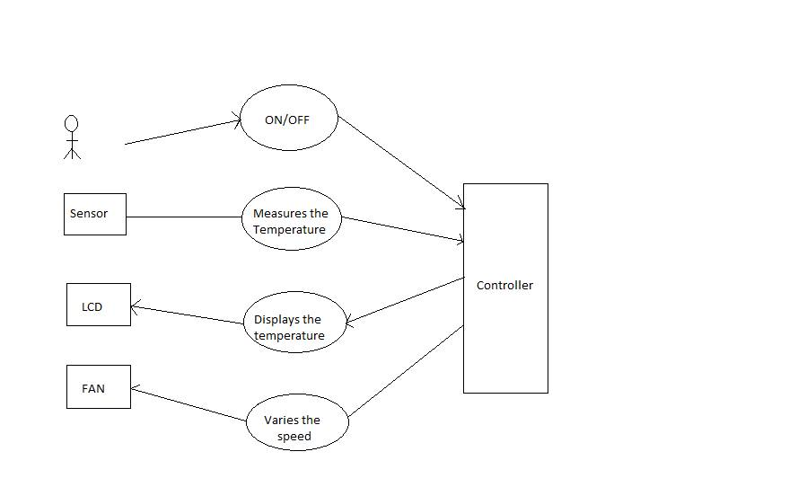

A.2 Adaptive fan Process Diagram

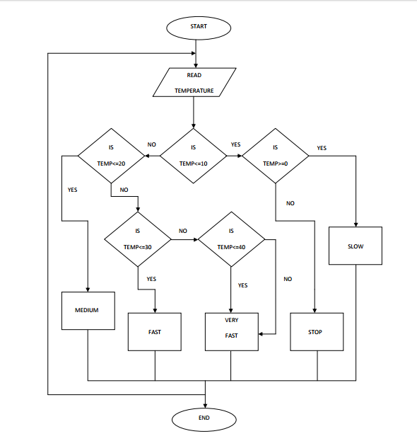

5.0 System Design:

In this project we are using

* Analog temperature sensor which senses the temperature around and the output of this sensor will be connected to a microcontroller.
* The AC to DC convertor converts the analog signals to Digital format. This will be used by microcontroller to generate control logic, here control logic refers to the implementation designed and coded involving all the constraints needed for different ranges of temperature. This helps in controlling variable speed DC motor of the fan through a motor driver stage.

6.0 Conclusion:

I would like to conclude that Adaptive fan will try to reduce unnecessary power consumption by fans and exhaustive adjusters which run continuously in many working places, This product helps those fans to sense the temperature around and regulate their speed which is appropriate in that temperature.

**7.0 References:**

1. International Journal of Computer Applications (0975 – 8887) Volume 81 – No5, November 2013.